

**Fig 5: Housing sites currently under construction and delivery against targets (April-Sept 2017)**

**There are currently 32 housing sites under construction.**

**The table above shows the year that construction commenced and how sites have performed in the last six months against targets for the same period.**

**Fig 4: Percentage of housing units with planning consent (outline or full)**

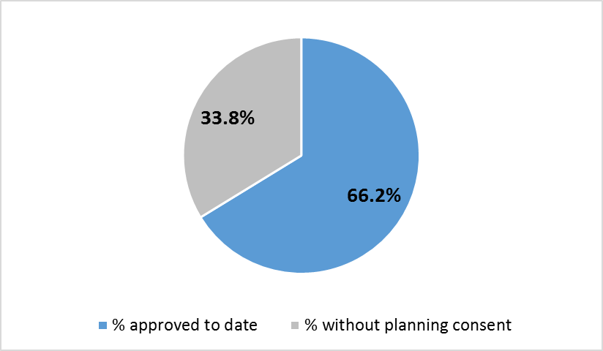

**100%=17,484**

**Units submitted for planning since April 2017 = 1115. (target 390)**

**Units consented since April 2017 = 1147 (target 400)**

**Fig 3: Housing and Employment sites progressing well**

|  |  |  |
| --- | --- | --- |
| **District** | **Details** | **RAG** |
|  | **HOUSING SITES** |  |
| SR | The masterplan for Moss side Test Track was approved by planning in July 2017 and outline anticipated by the end of the year |  |
| PR | All NW Preston sites are progressing well, Haydock Grange is progressing particularly quickly and Eastway is also performing well. |  |
| SR | Altcar lane has gained outline planning permission and reserved matters submission s expected in the near future |  |
| SR | The southern end of the Croston Road site is progressing at pace and the HCA is looking at options to facilitate the delivery of the spine road on the northern section of the site. |  |
|  | **EMPLOYMENT SITES** |  |
| PR | Red Scar – Phase 2 completed following strong occupation of Phase 1 |  |
| PR | Preston East (Sector D) – commenced on site |  |
| PR | UCLAN Campus (Engineering Innovation College) – commenced on site |  |
| SR | South Rings employment site – commenced on site |  |
| PR | Horrocks Development – Phase 2 completed |  |

**Fig 2: Housing and employment sites – sites identified as amber or red (issues and responses)**

|  |  |
| --- | --- |
|  | **Site details and issues identified that could affect delivery**  Activities underway to mitigate risks and issues. |
|  | **Housing** |
|  | **Pickerings Farm *(1200 units*)**: This site remains in the pre-application stage. Although progressing slower than expected start on site is still proposed in year 7-2020/21. A site steering group in place for this site to facilitate delivery. |
|  | **Vernon Carus phases 1/2/3**: **(385 units**) Bovis is actively marketing this site therefore it is unlikely that discharge of permissions will take place in next 6 months as originally anticipated. Build is currently profiled to commence in year 5 2018/19. Site unlikely to deliver as anticipated. |
|  | **Mixed use – housing and employment** |
|  | **Whittingham Hospital (Ph2/3) *(500 units + retail*)** Viability concerns around this site. A new planning application is expected. Will affect agreed s106. LCC and PCC continue to work closely with HCA to progress matters |
|  | **Various small sites:** * (***total 209 units***) A number of smaller sites are not progressing as quickly as anticipated due to a variety of reason. Site constraints, no live planning permission or non-receipt of application. These sites continue to be monitored by planning officers and sites may need to be re-profiled if they do not progress. |
|  | **Employment** |
|  | **Cottam Hall Supermarket (Brickworks site)** (***6105sq m)***  **Cottam Hall A3/A4/A5** (District Centre) ***(1380sq m)***  **Cottam Hall** - D1/D2 ***(2052sq m)***  The site has planning consent, but works haven't commenced on site. All milestones for Cottam Brickworks Phase 1 have been pushed back by around 21 months.  The project manager is in dialogue with HCA to progress next steps. |
|  | **Bluebell Way** (LCC site) ***(5000sq m***) Disposal of this property has been delayed as it was remarketed and HOT are being negotiated with a new party. Construction milestones unknown at this stage but site remains attractive to the market and end users. |
|  | **Winckley Square – Phase 2** (Winckley Square) ***(sq m tbc)***  Milestones related to College House, essential repairs have been undertaken but there is no known developer engagement. |

The Development sites delivery group (DSDG) continue to monitor risks that are significant to City Deal and work with partners and developers to formulate appropriate responses.

*Small sites (209 units) refer to the following: Cottam brickworks, Skeffington Rd/Castleton Rd, Shelley Rd/Wetheral St, Ashton Basin, Tulketh Brow, Land off School lane, Longton.

**Fig. 1 - Housing delivery progress up to Sept 2017**

|  |  |  |  |  |  |  |  |  |  |  |
| --- | --- | --- | --- | --- | --- | --- | --- | --- | --- | --- |
|  |  | |  |  | | --- | --- | |  | No. of units where 'delivery is on target'. Either on site or planning is progressing as anticipated. | |  | No. of units on sites where 'issues have been identified or progress slower than expected'  *see table below | |  | Units with no milestones in current year. No issues identified. | |  | Total number of units completed to date |   Overall target units=  **17, 484** |

**Units completed between 1 April – 30 Sept 2017 = 434 against a target of 503**

**City Deal housing and employment site performance summary – April - Sept 2017**  **Appendix 2**